

H7E1 04

Software solution Development with a Database Management System (DBMS)

SOFTWARE APPLICATION DEVELOPMENT

H7E1 04/AS/02

Use Case Diagram

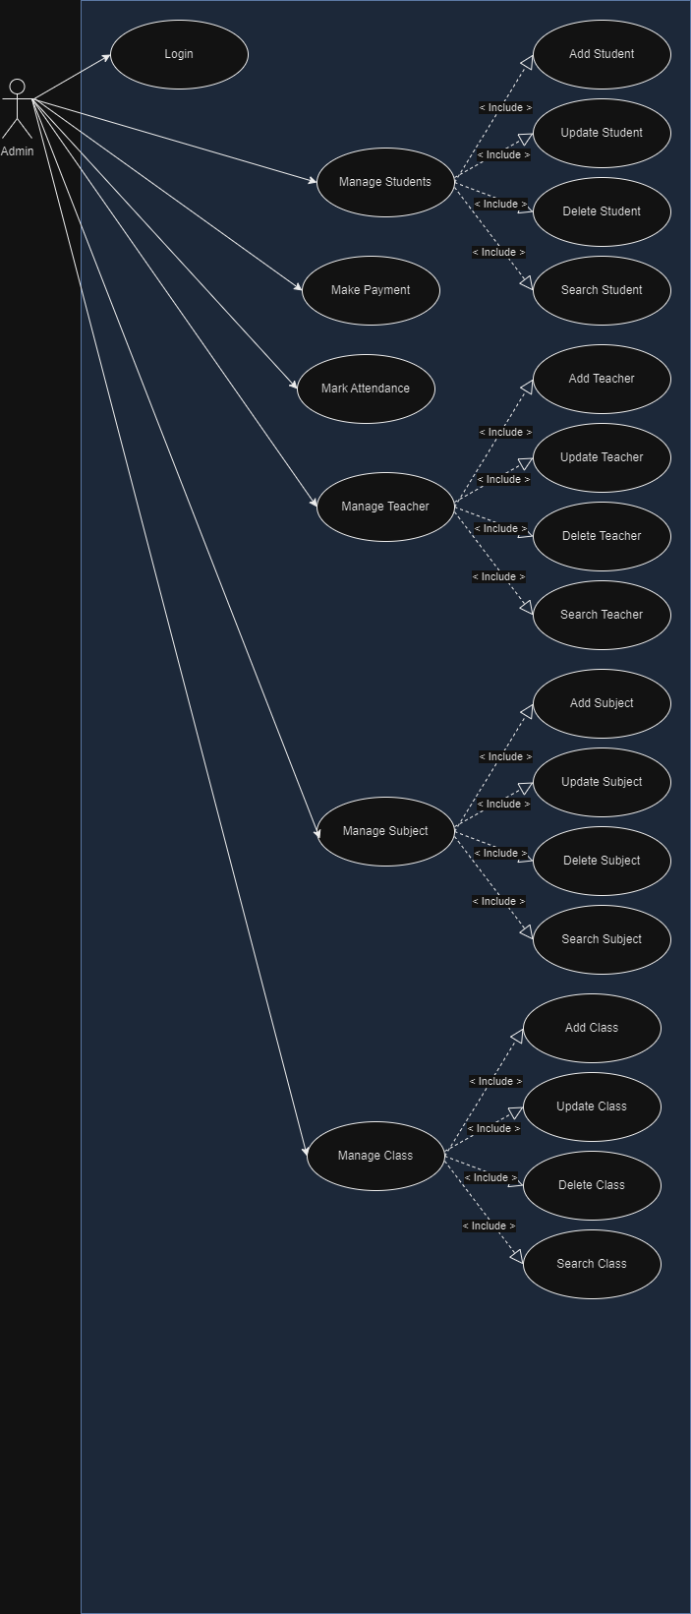

Activity Diagram

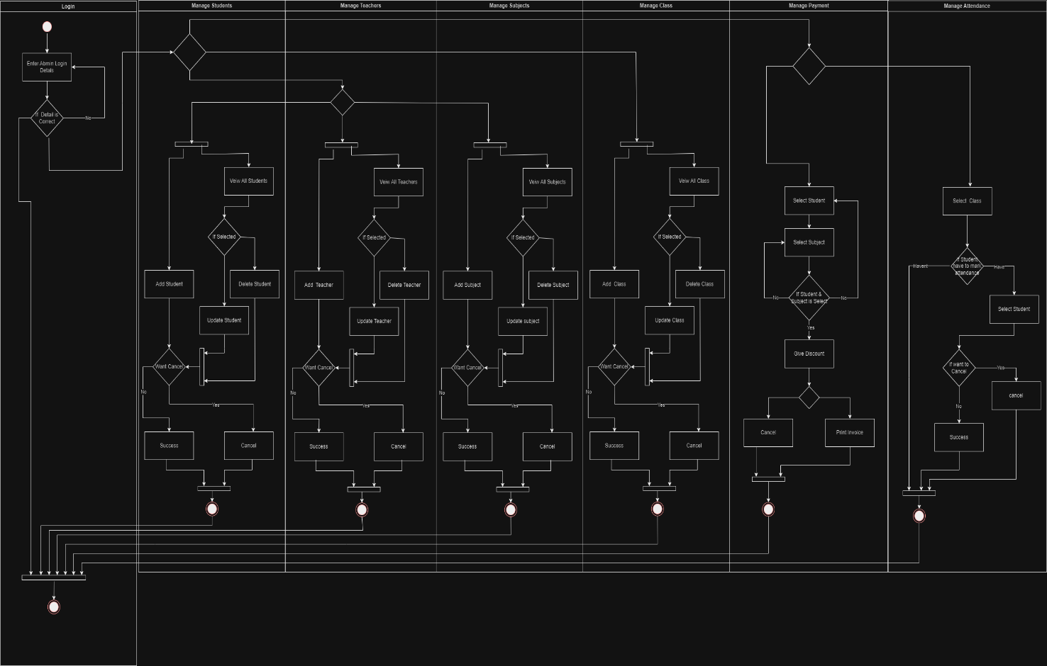

ER Diagram

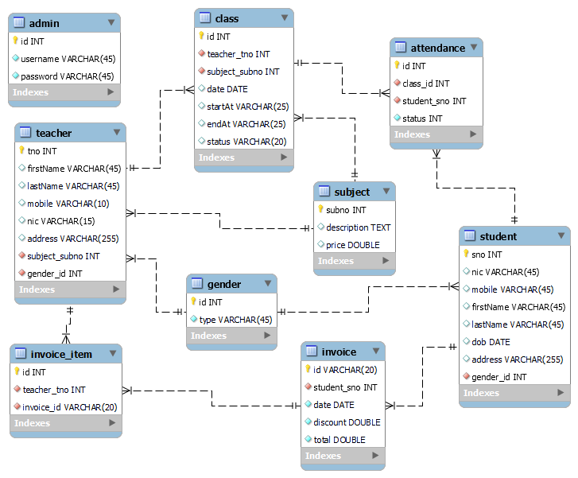

**Admin Login Page**

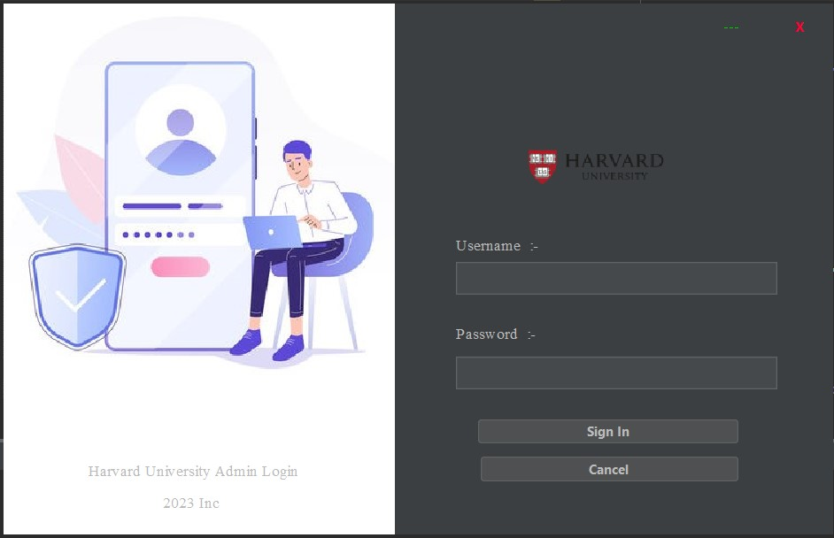

02. Login Cancel Btn

1. Login SignIn Btn
2. Login SignIn Btn

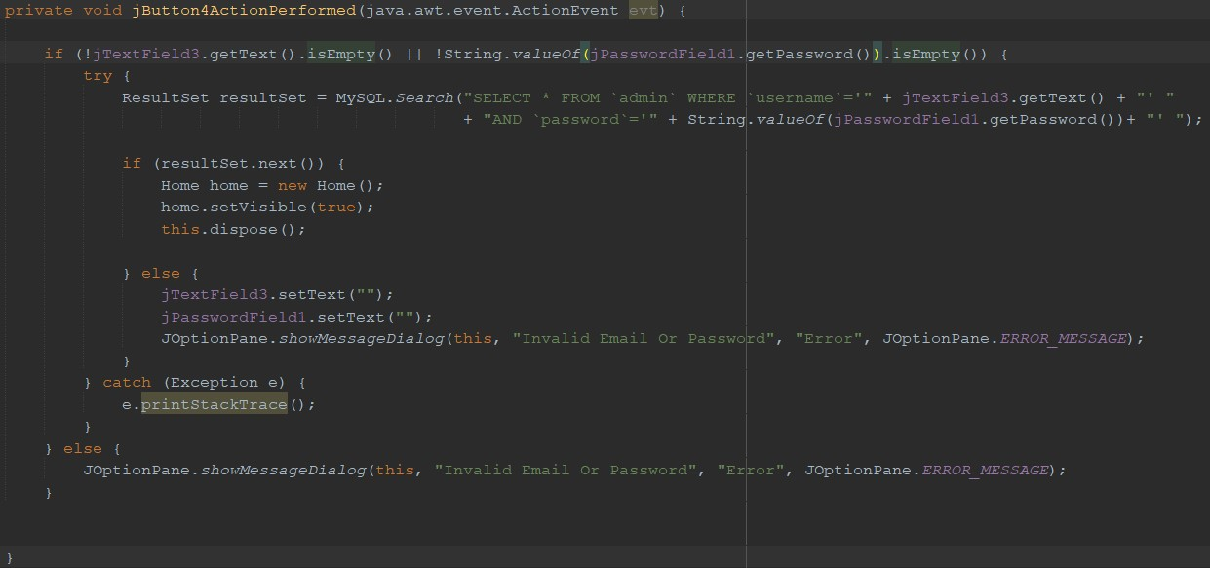

1. Login Cancel Btn



**Home Page**

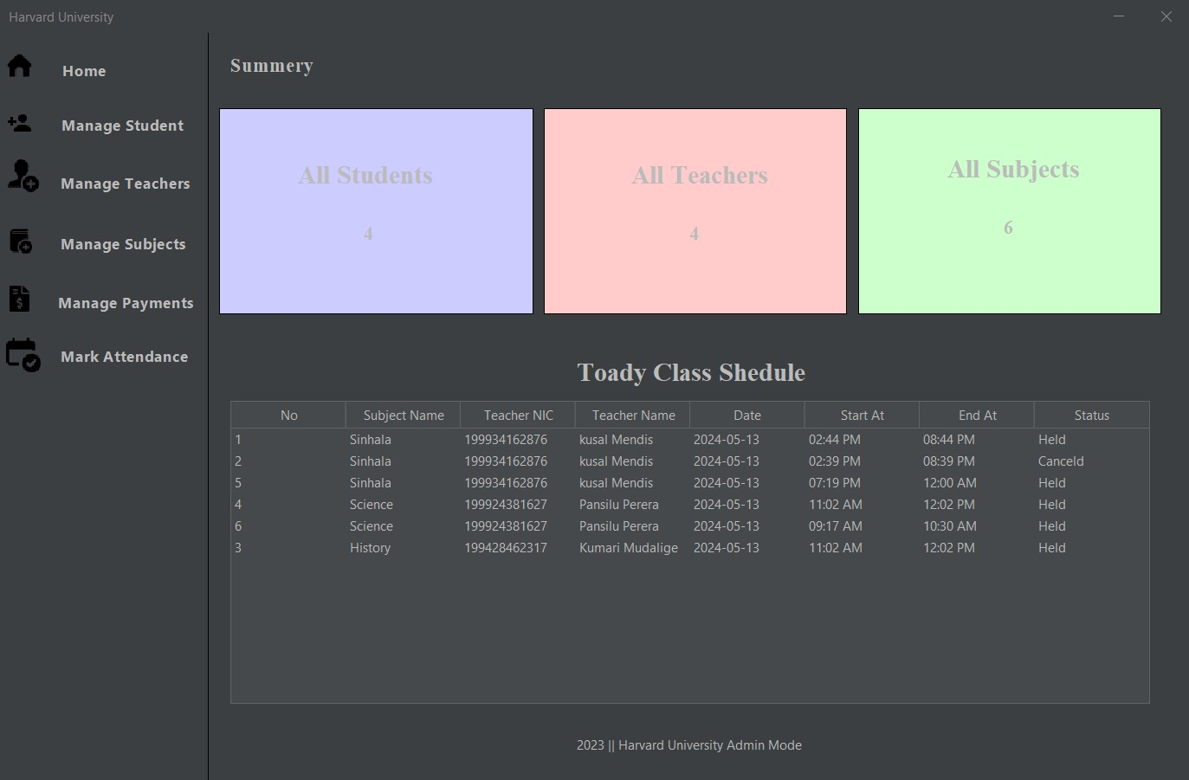

01. Home Page Load

1. Home Page Load

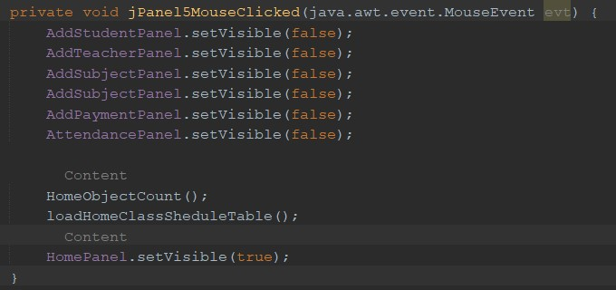

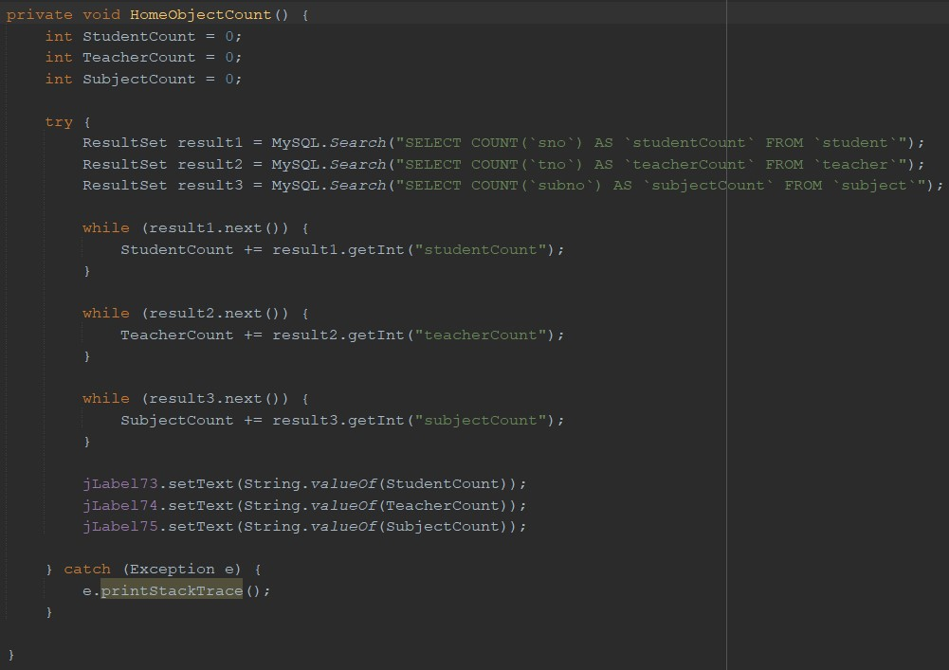

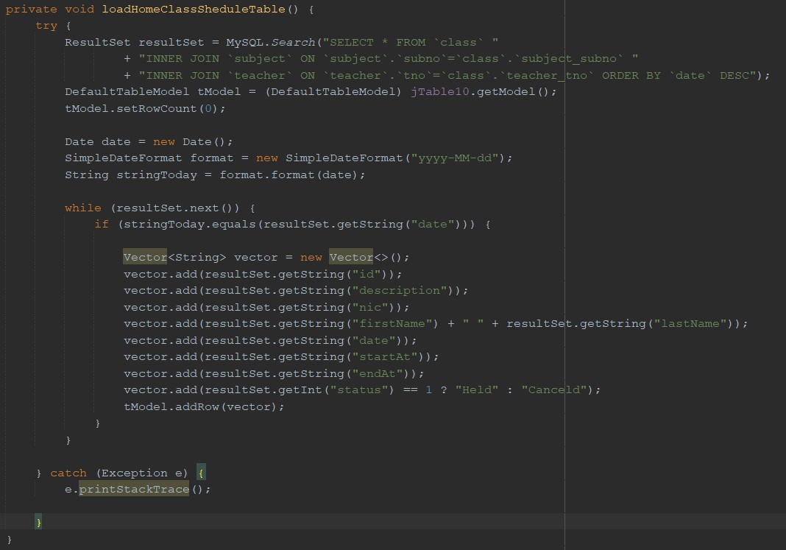

**Manage Students Page**

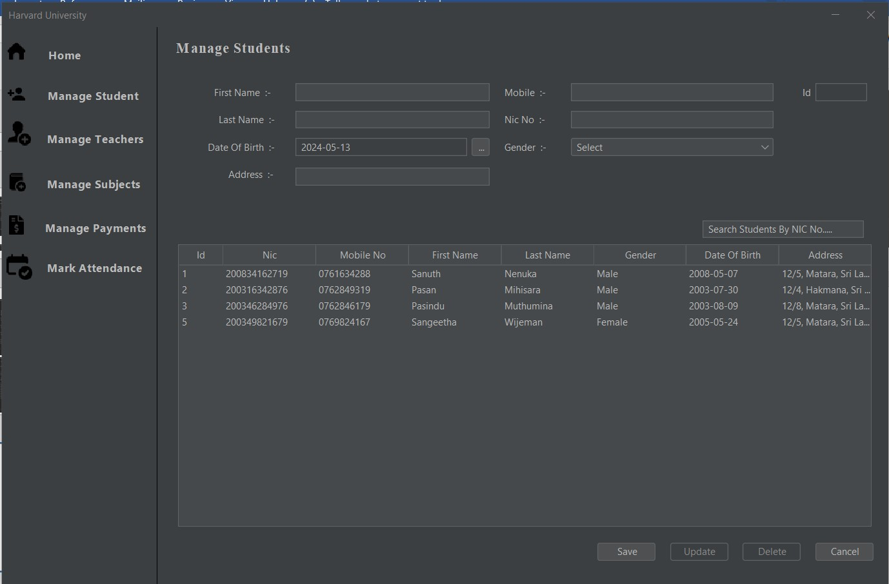

07. Student Search

06. Student Cancel Btn

05. Student Delete Btn

04. Student Update Btn

02. Student Save Btn

1. Manage Student Btn

03. Select Student

1. Manage Student Btn

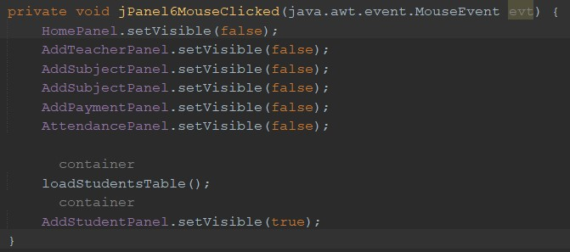

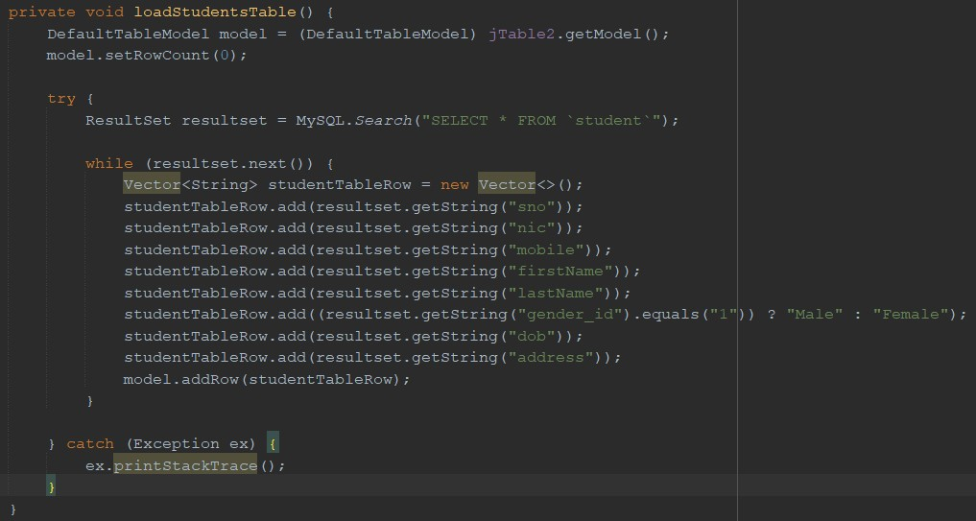

02. Student Save Btn

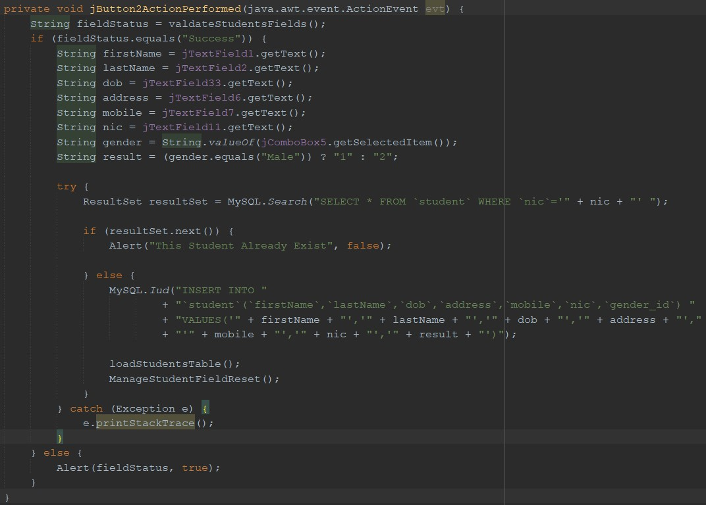

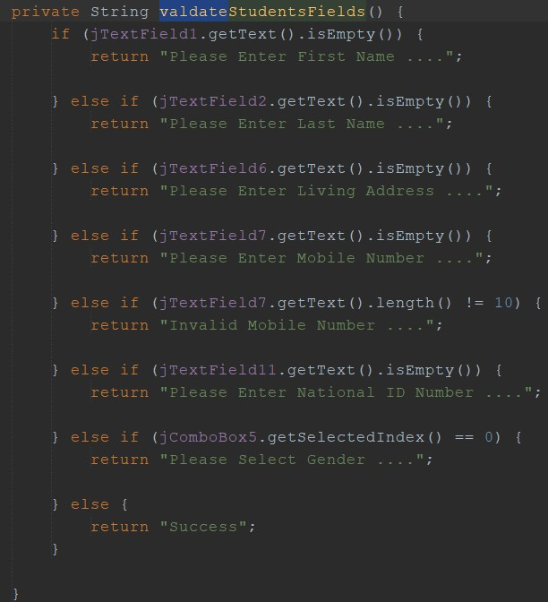

1. Select Student

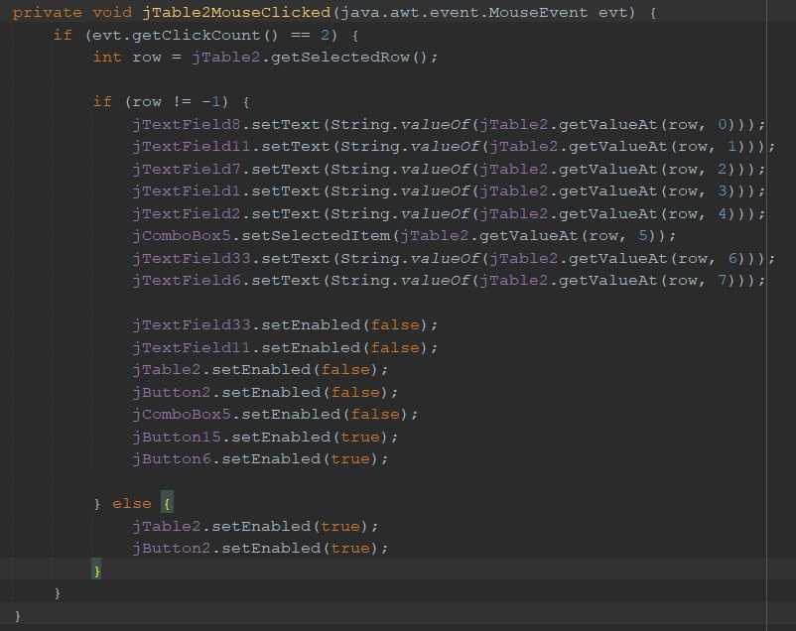

1. Student Update Btn

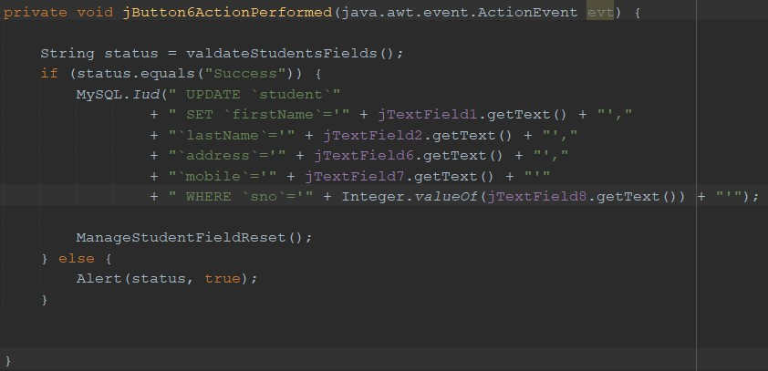

1. Student Delete Btn



1. Student Cancel Btn

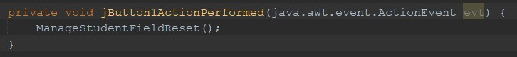

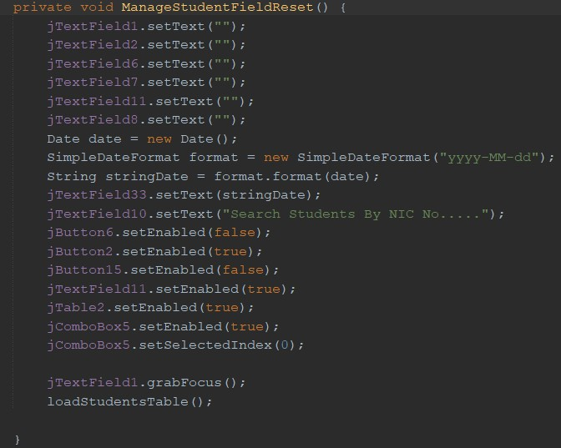

1. Student Search

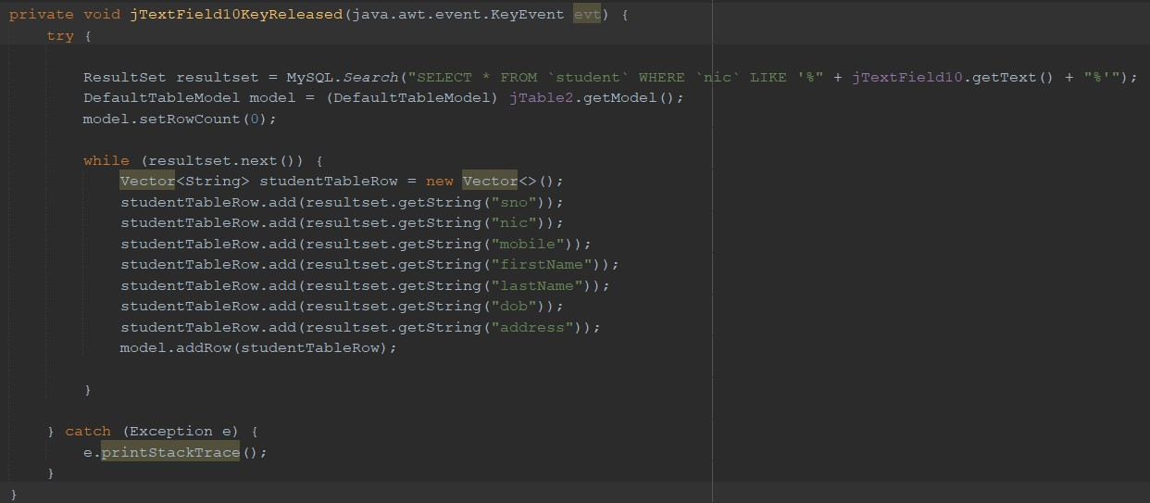

**Manage Teachers Page**

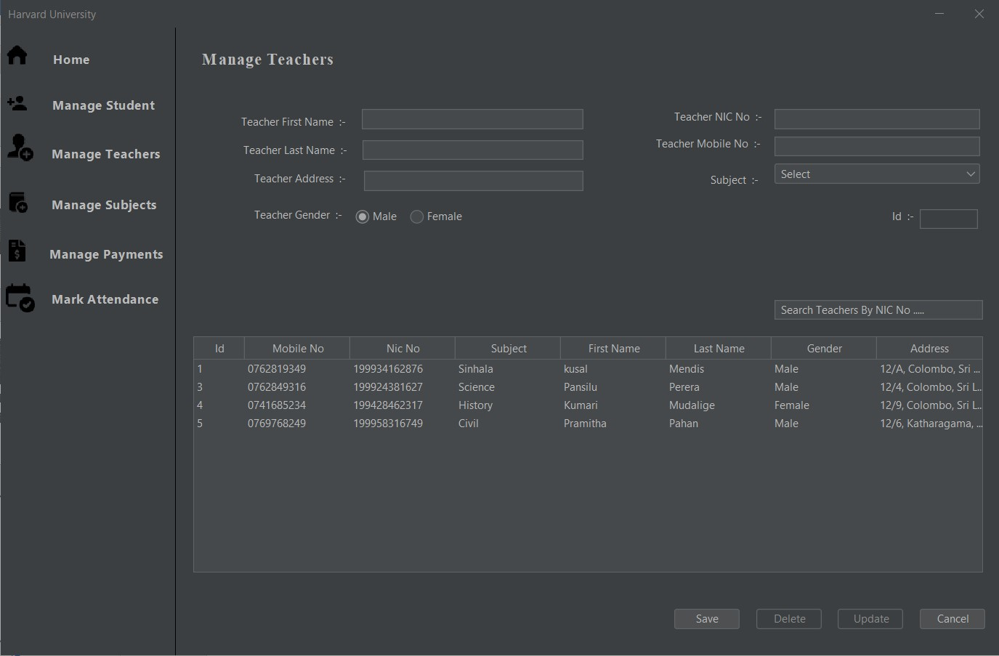

05. Teacher Update Btn

07. Teacher Search

04. Teacher Delete Btn

03. Select Teacher

06. Teacher Cancel Btn

02. Teacher Save Btn

1. Manage Teacher Btn
2. Manage Teacher Btn

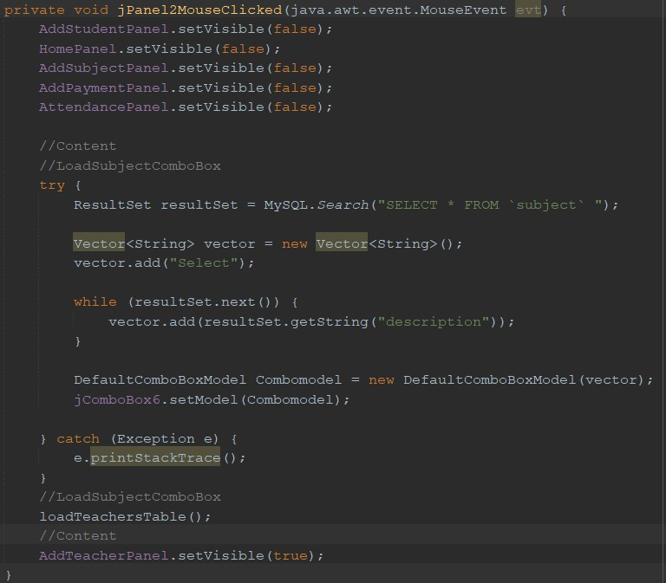

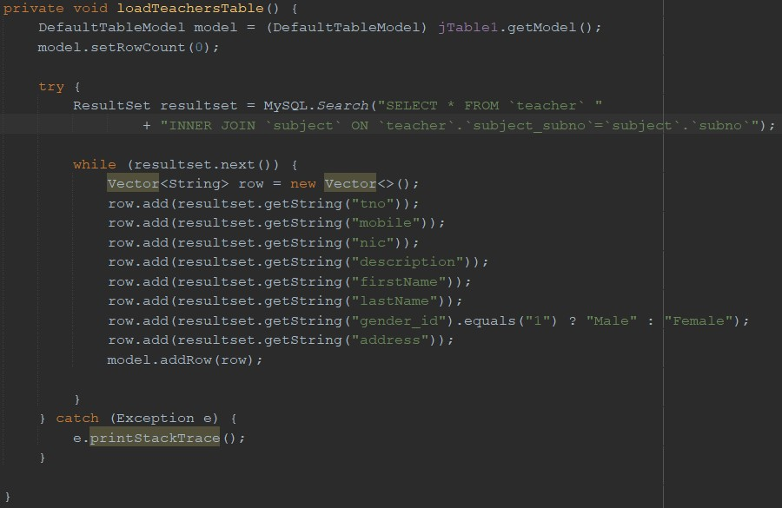

1. Teacher Save Btn

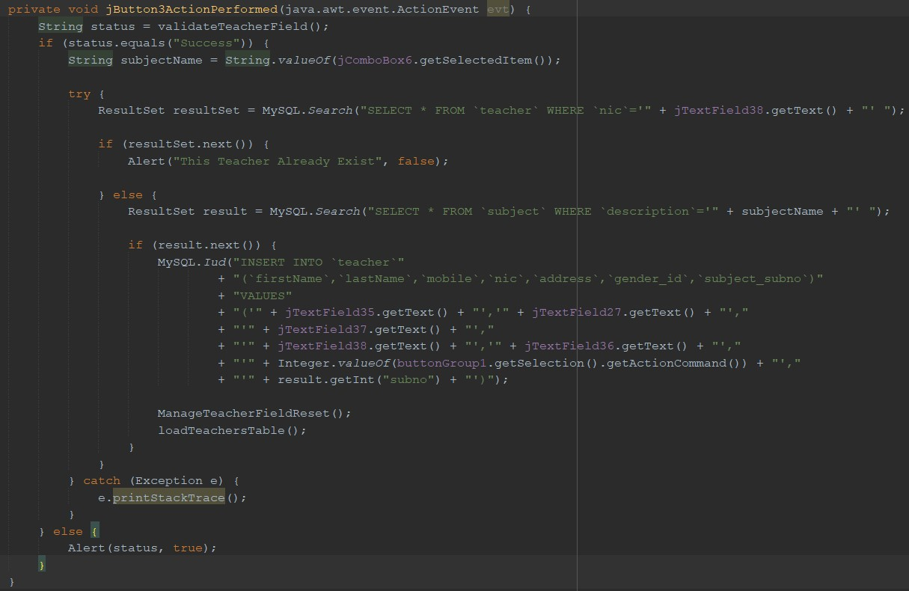

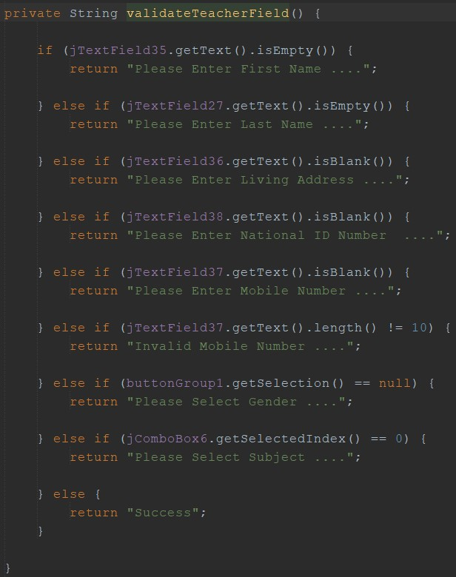

1. Select Teacher

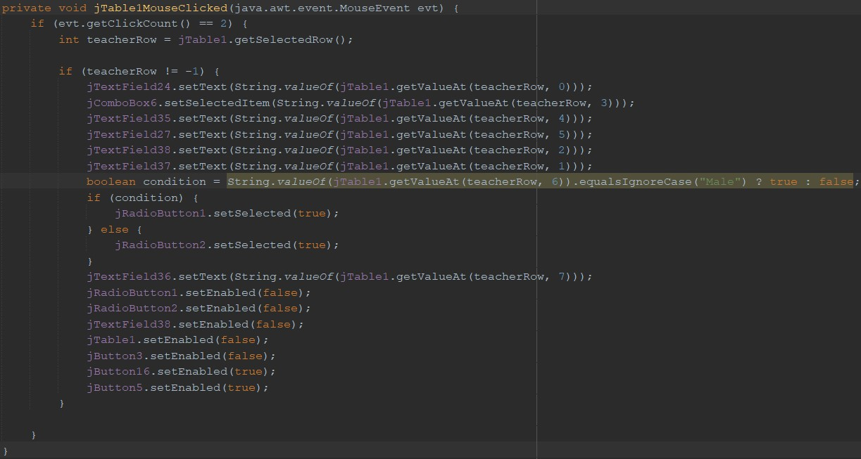

1. Teacher Delete Btn

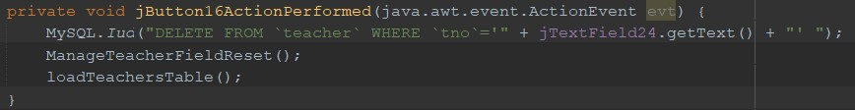

1. Teacher Update Btn

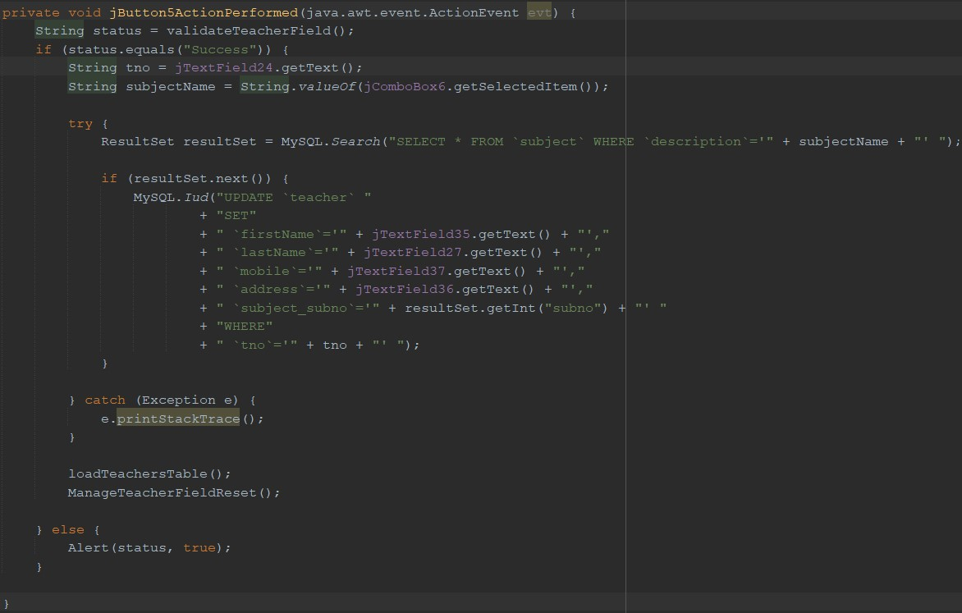

1. Teacher Cancel Btn

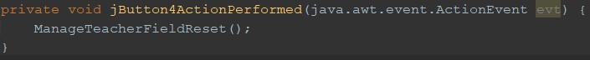

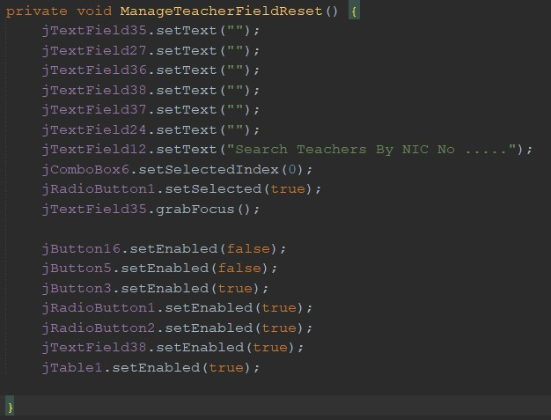

1. Teacher Search

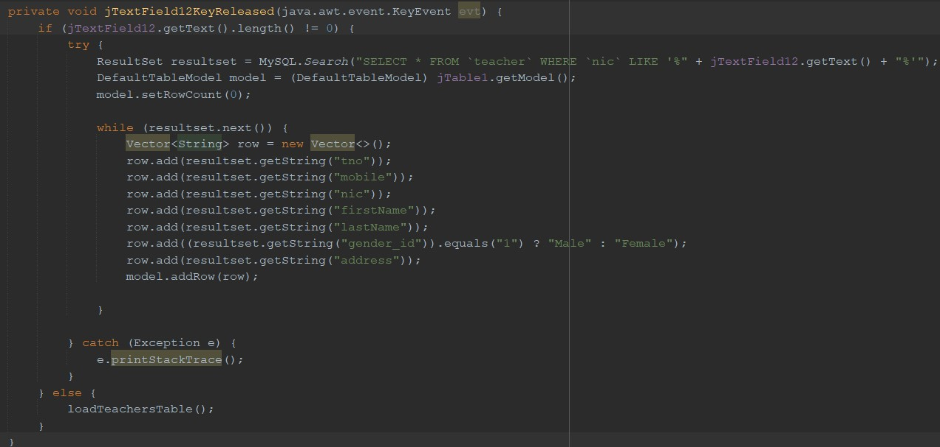

**Manage Teachers Page**

1. Manage Subject Btn

07. Select Subject

05. Cancel Subject Btn

03. Delete Subject Btn

06. Search Subject

04. Update Subject Btn

02. Save Subject Btn

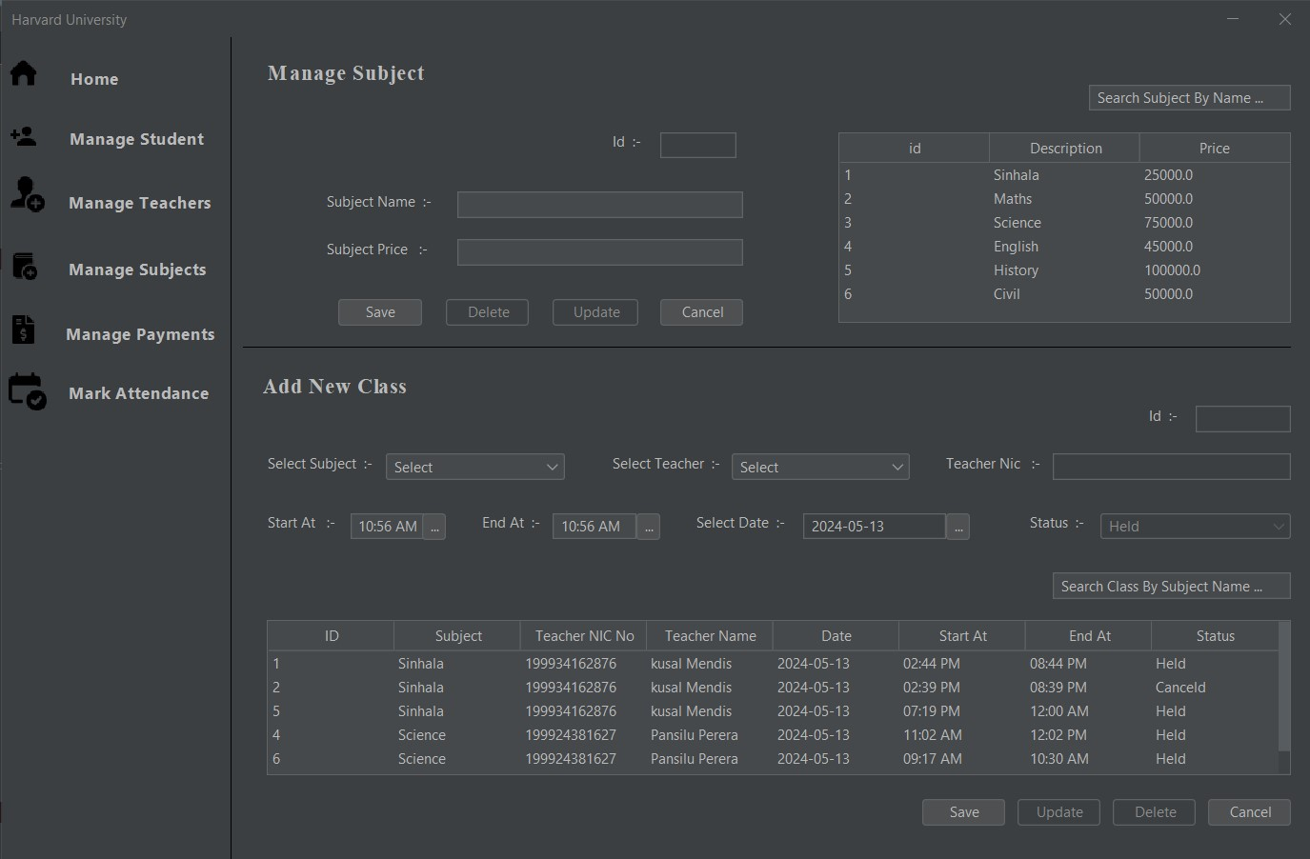

09. Class Search

06. Class Select

05. Class Save Btn

02. Select Class Start Btn Time

03. Select Class End Time Btn

04. Select Class Held Date Btn

07. Class Update Btn

08. Class Delete Btn

09. Class Cancel Btn

01. Add Class To Select Subject

1. Manage Subject Btn

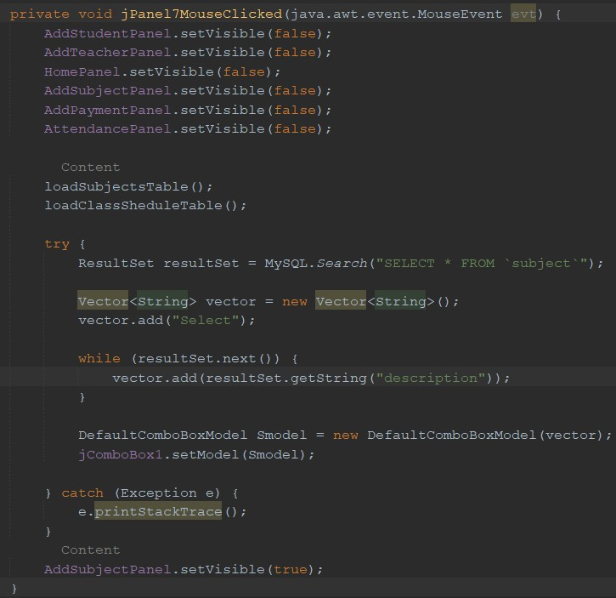

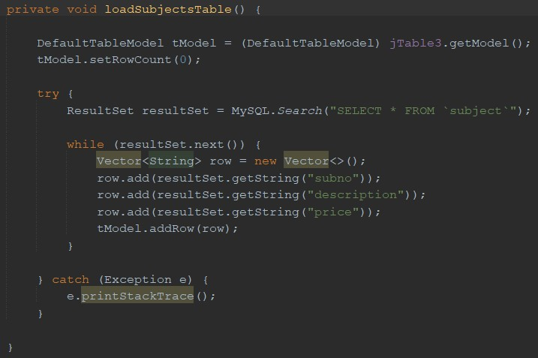

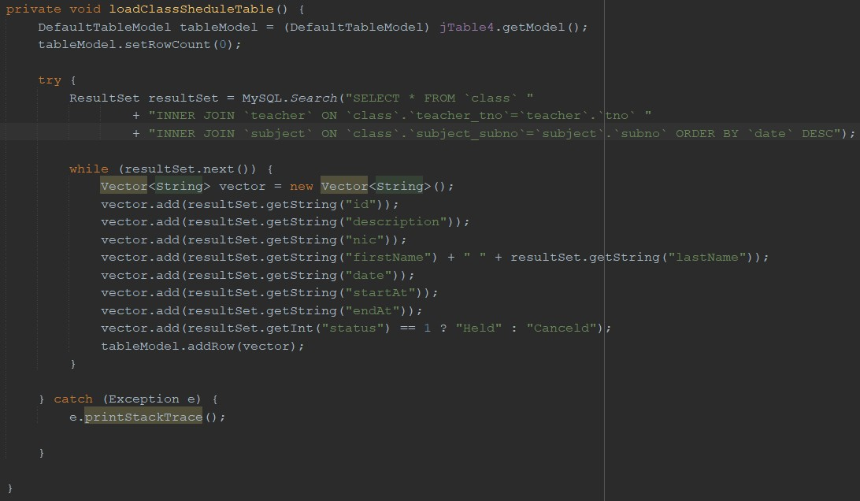

02. Save Subject Btn

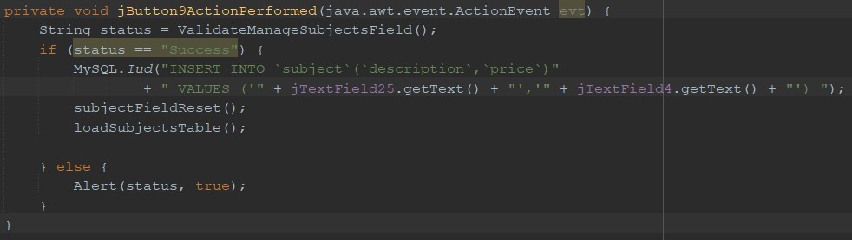

03. Delete Subject Btn

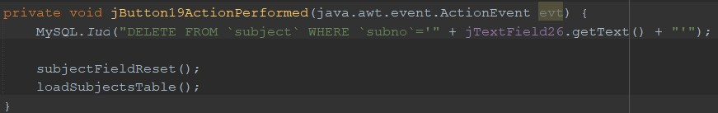

04. Update Subject Btn

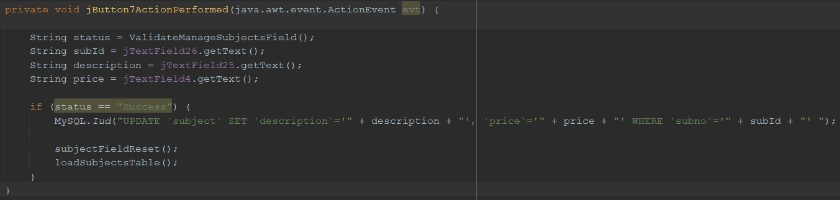

05. Cancel Subject Btn

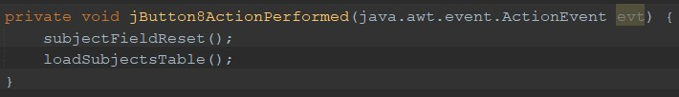

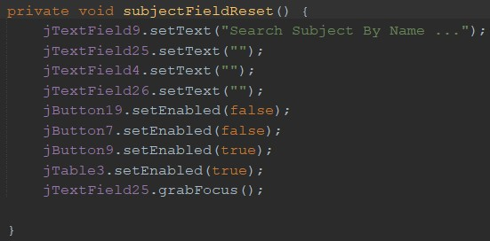

06. Search Subject

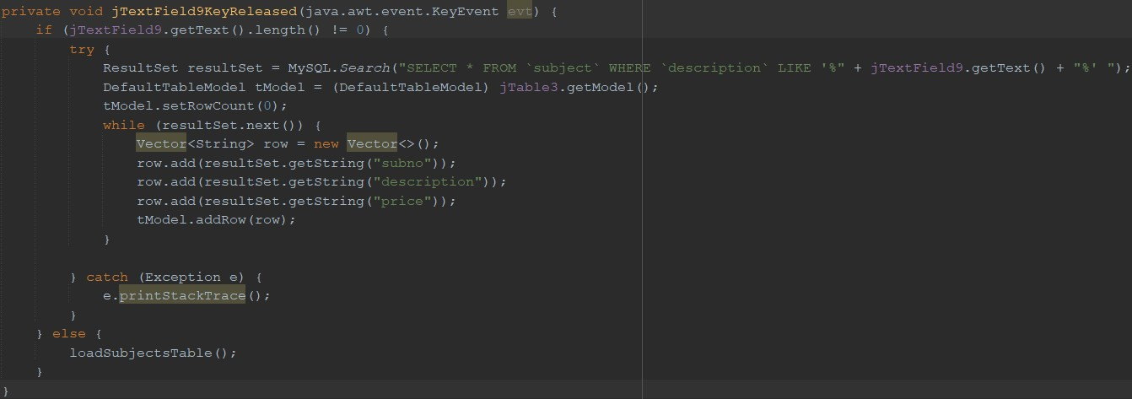

07. Select Subject

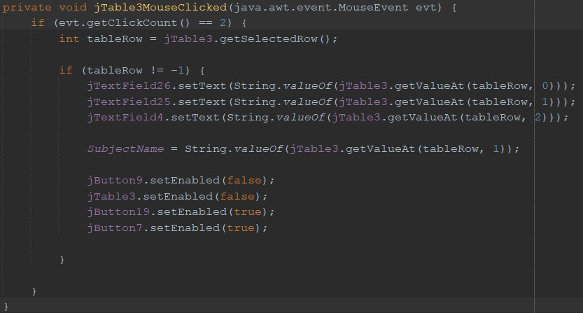

01. Add Class To Select Subject

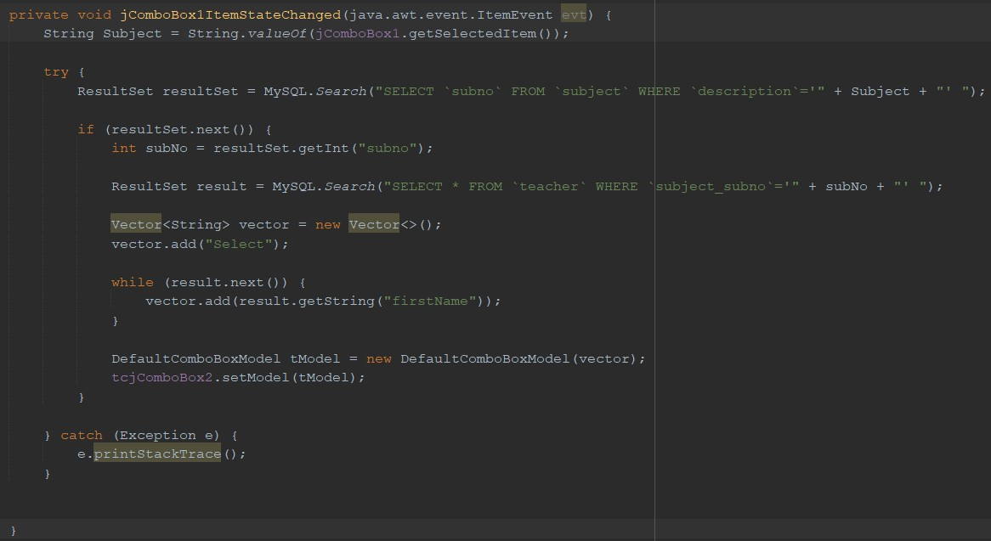

02. Select Class Start Btn Time



03. Select Class End Time Btn



04. Select Class Held Date Btn



05. Class Save Btn

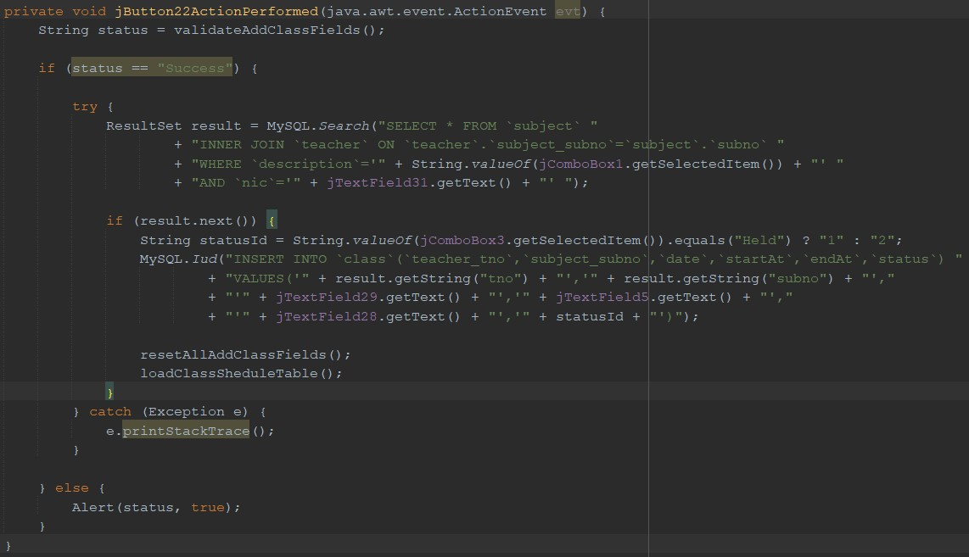

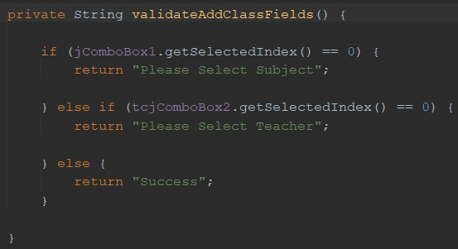

07. Class Update Btn

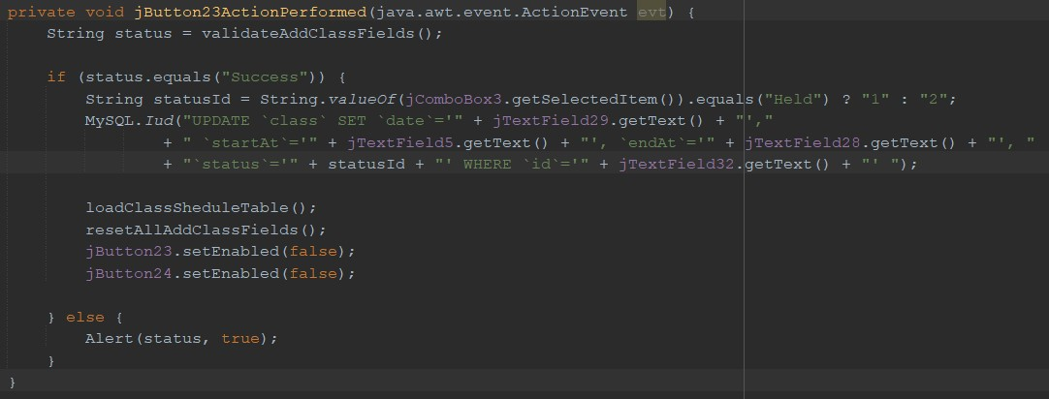

08. Class Delete Btn

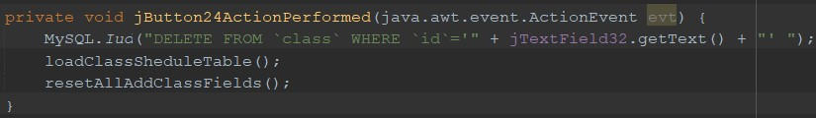

09. Class Cancel Btn

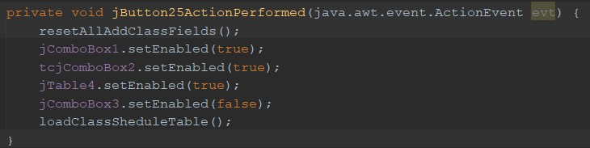

09. Class Search

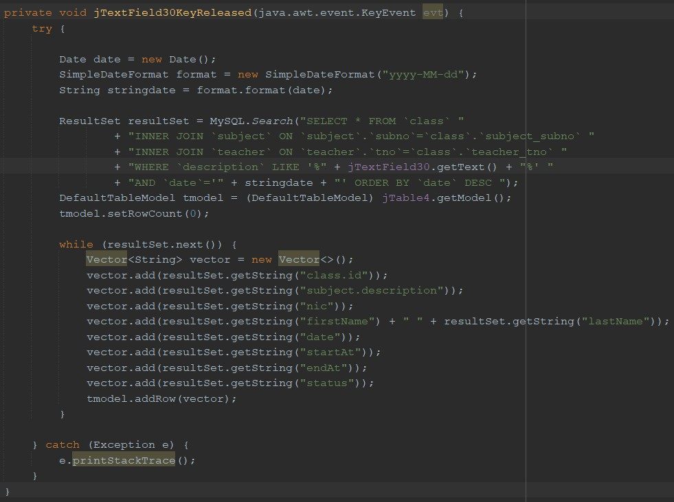

**Manage Payment Page**

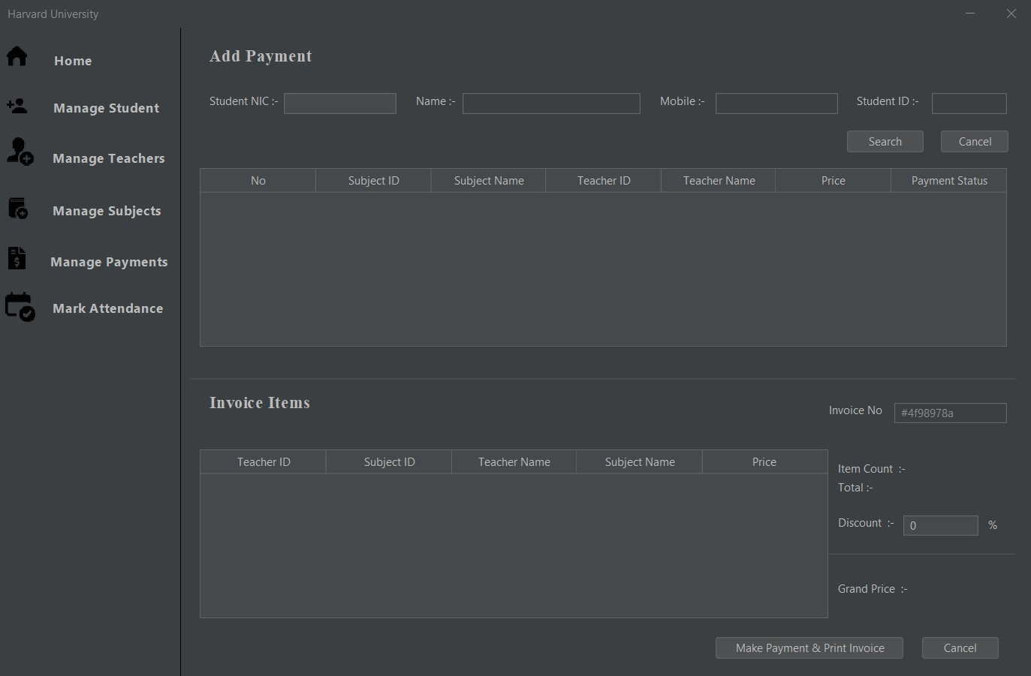

07. Make Payment Btn

08. Cancel All Btn

05. Select Subject

06. Add Discount

04. Cancel Student Btn

03. Search Student Have To Pay Subjects Btn

02. Search Student

01. Manage Payment Btn

1. Manage Payment Btn

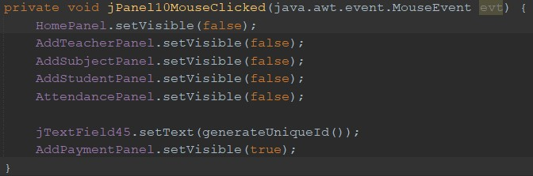

1. Search Student

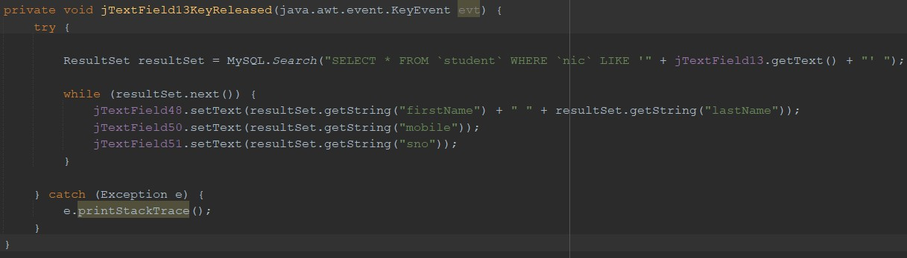

1. Search Student Have To Pay Subjects Btn

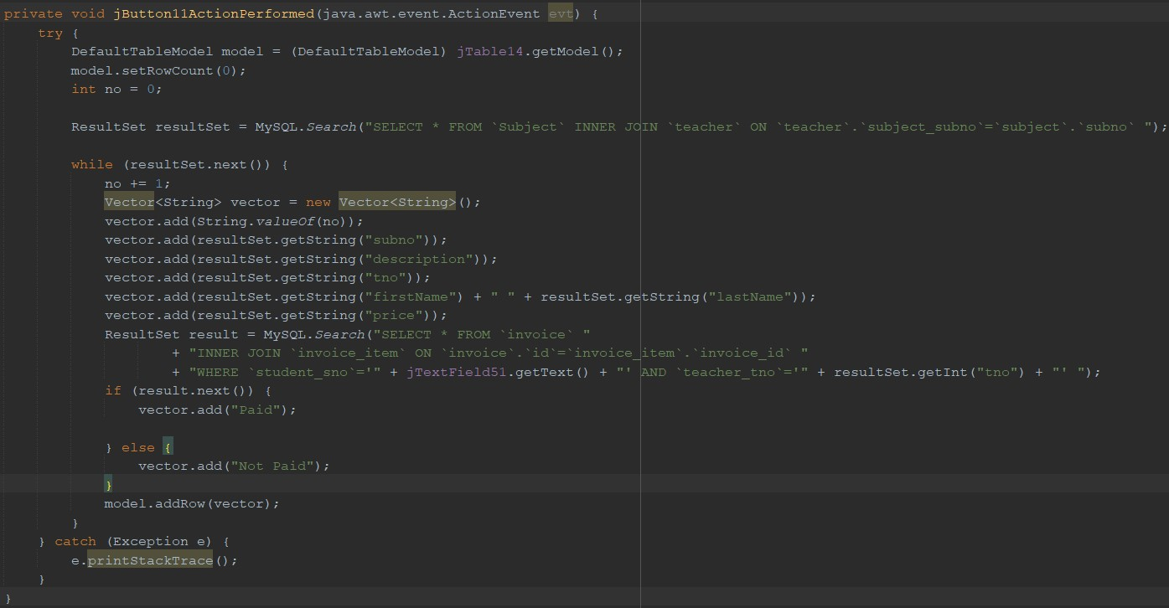

1. Cancel Student Btn

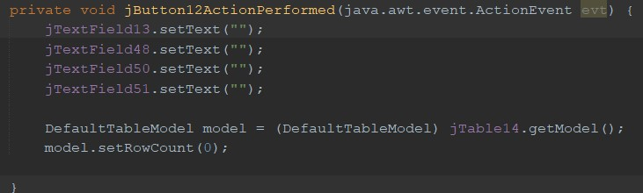

1. Select Subject

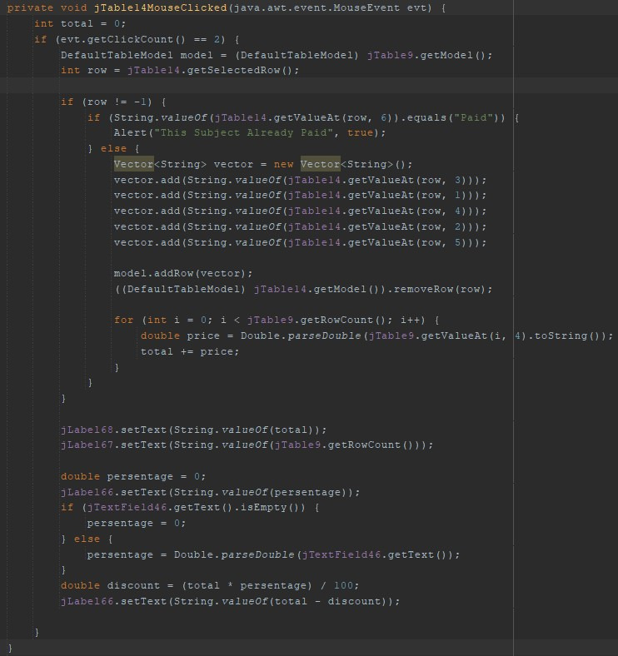

1. Add Discount

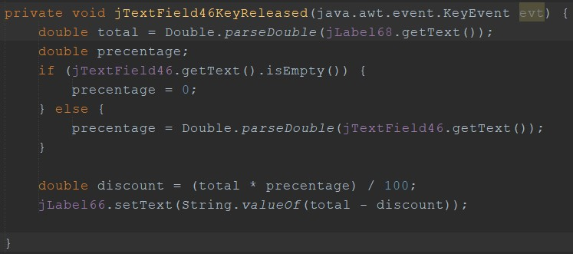

1. Make Payment Btn

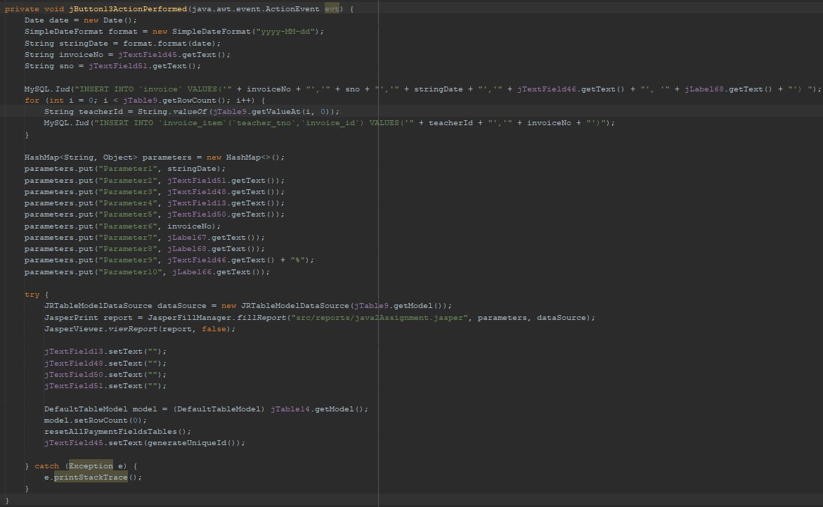

1. Cancel All Btn

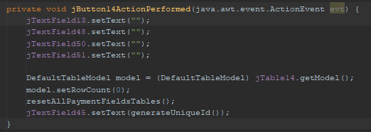

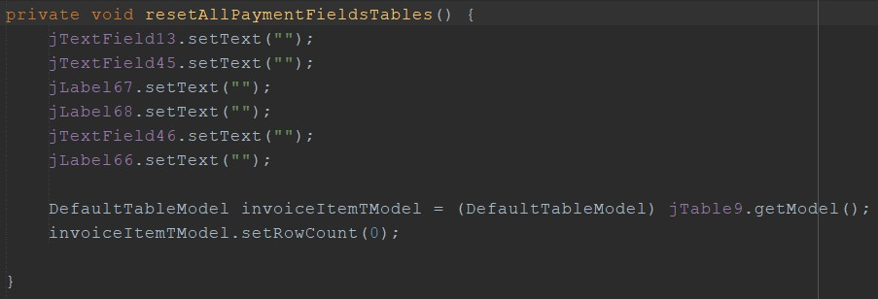

**Manage Attendance Page**

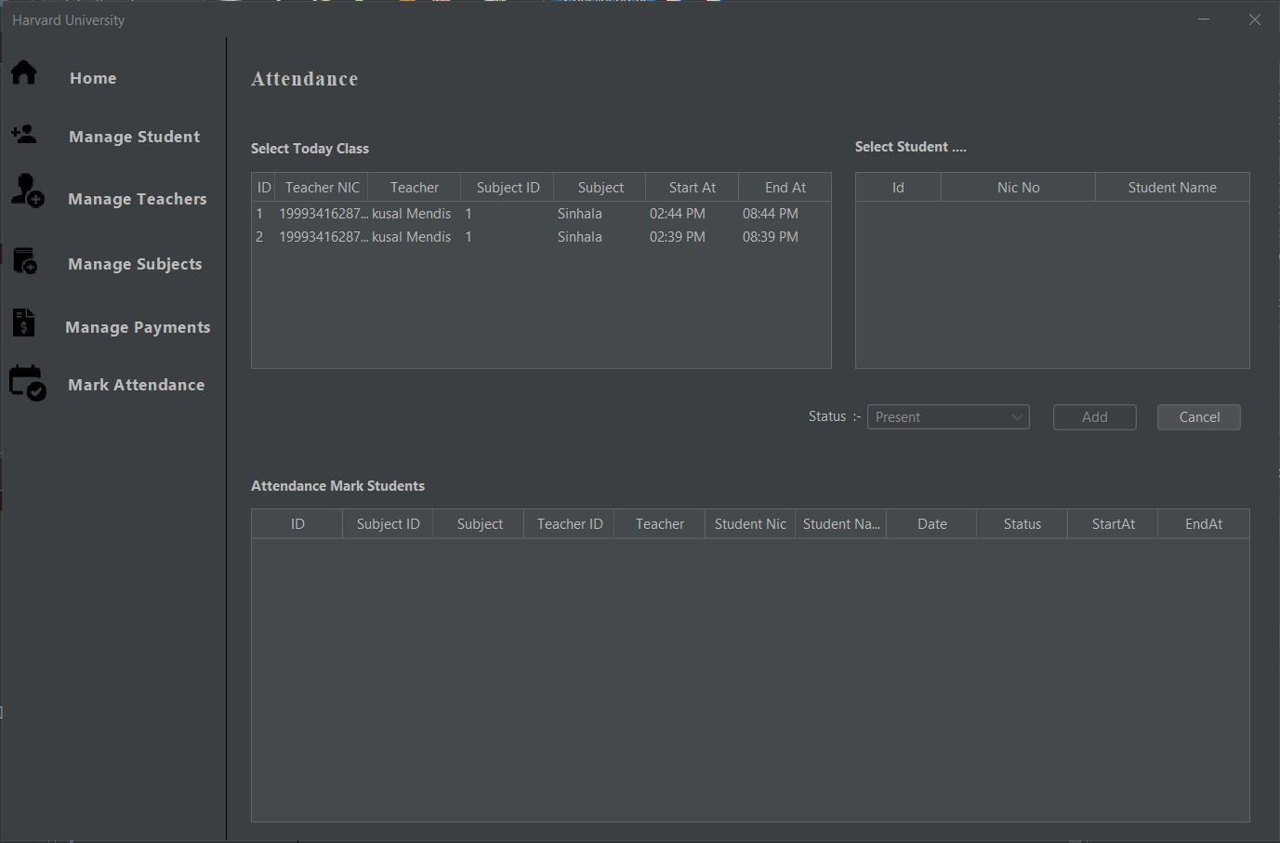

04. Mark Attendance Btn

05. Cancel Btn

03. Select Student

02. Select Class

1. Manage Attendance Btn
2. Manage Attendance Btn

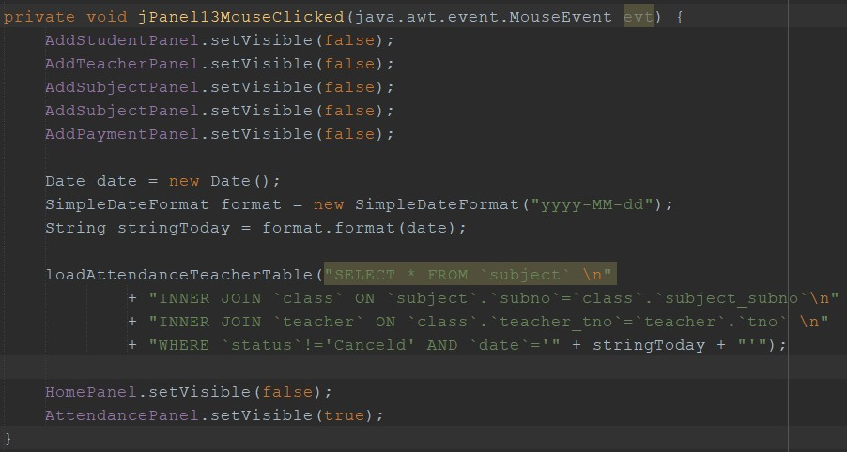

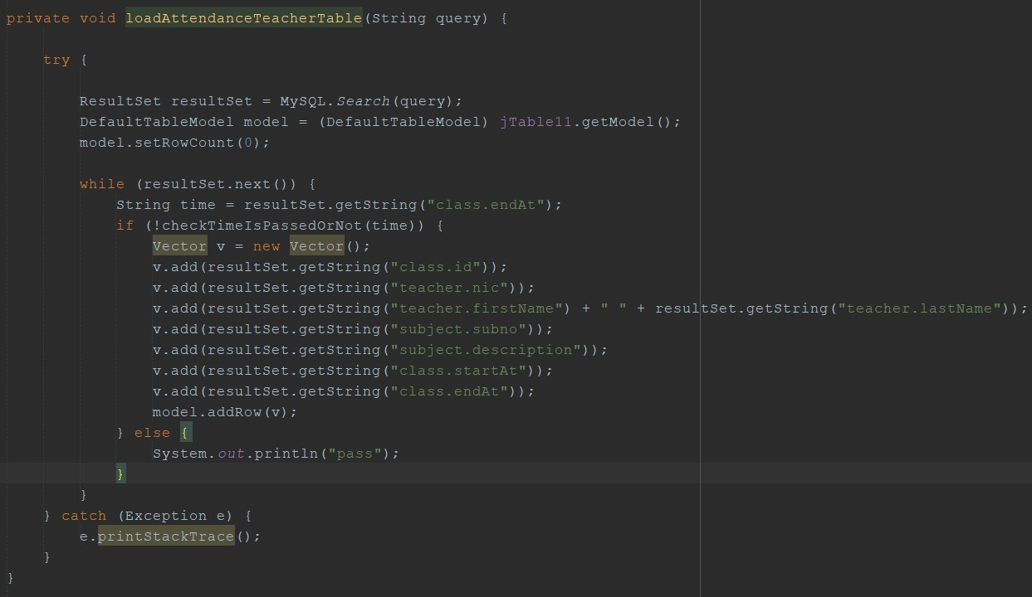

1. Select Class

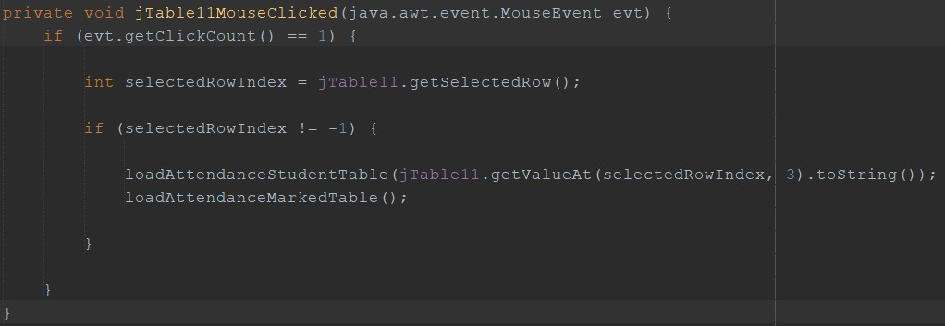

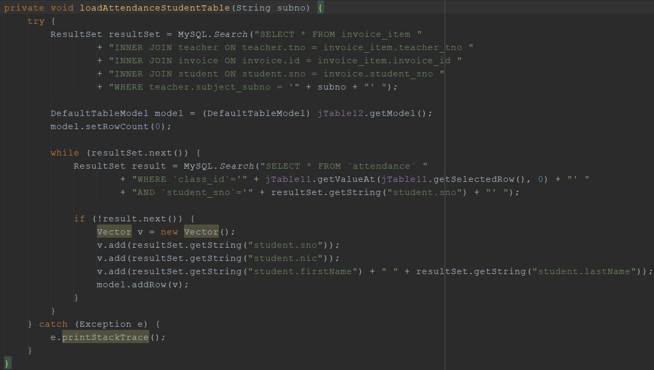

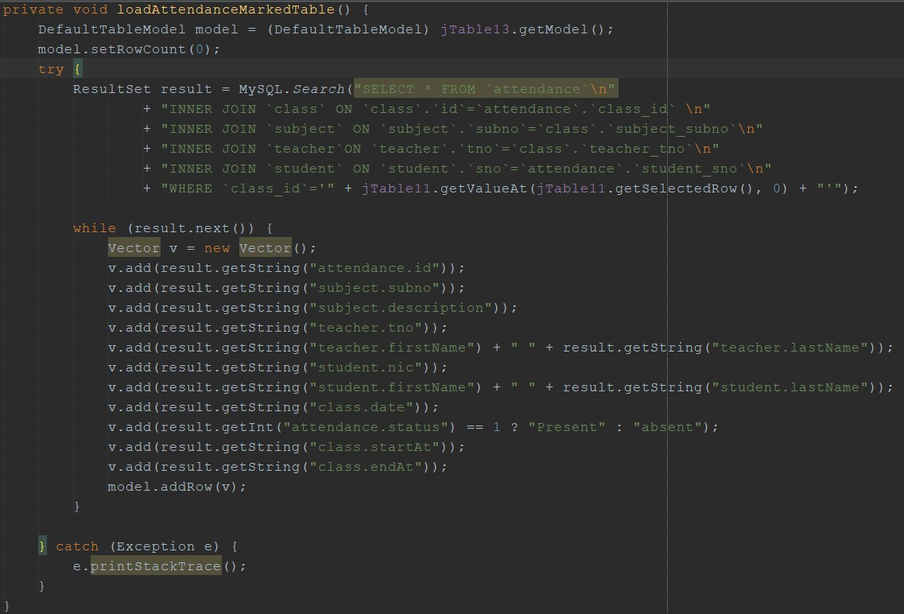

1. Select Student

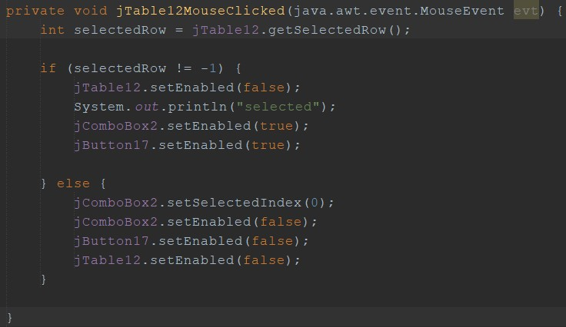

04. Mark Attendance Btn

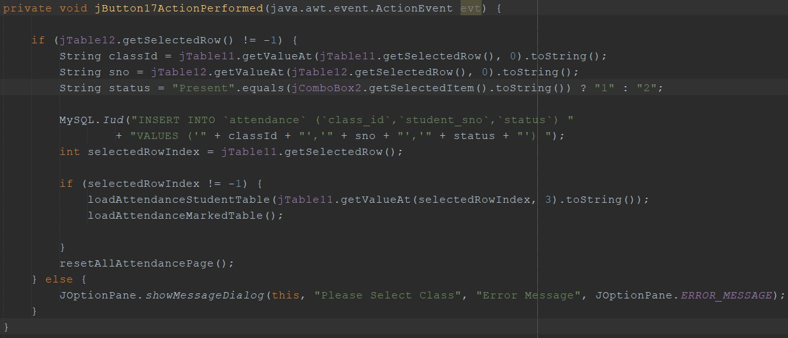

05. Cancel Btn

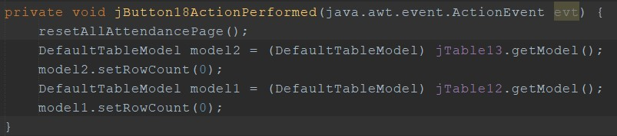

**THANK YOU**